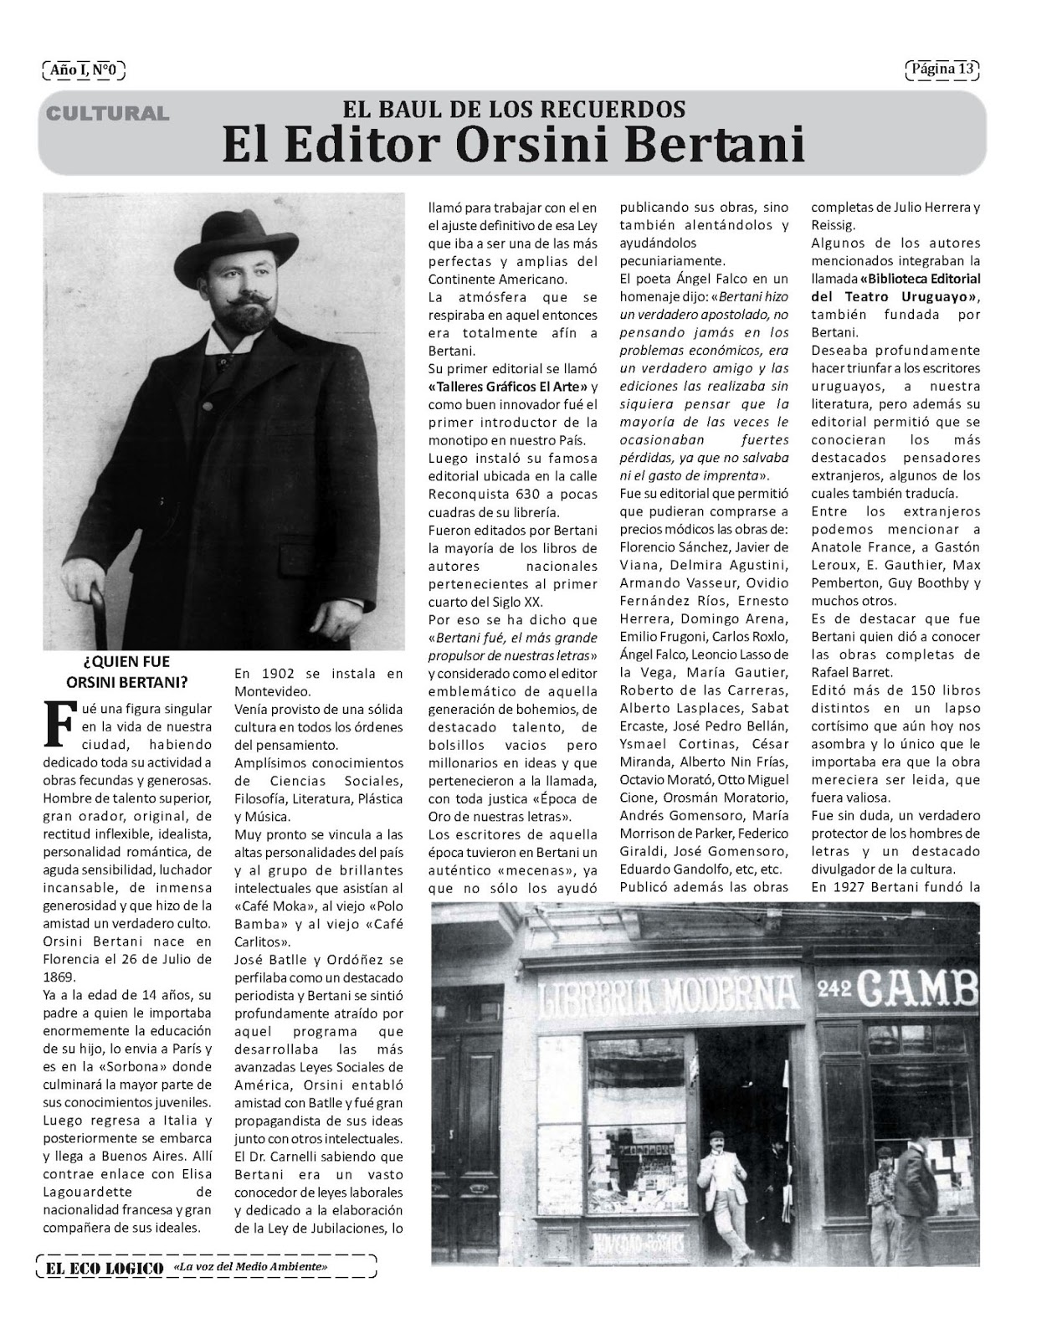

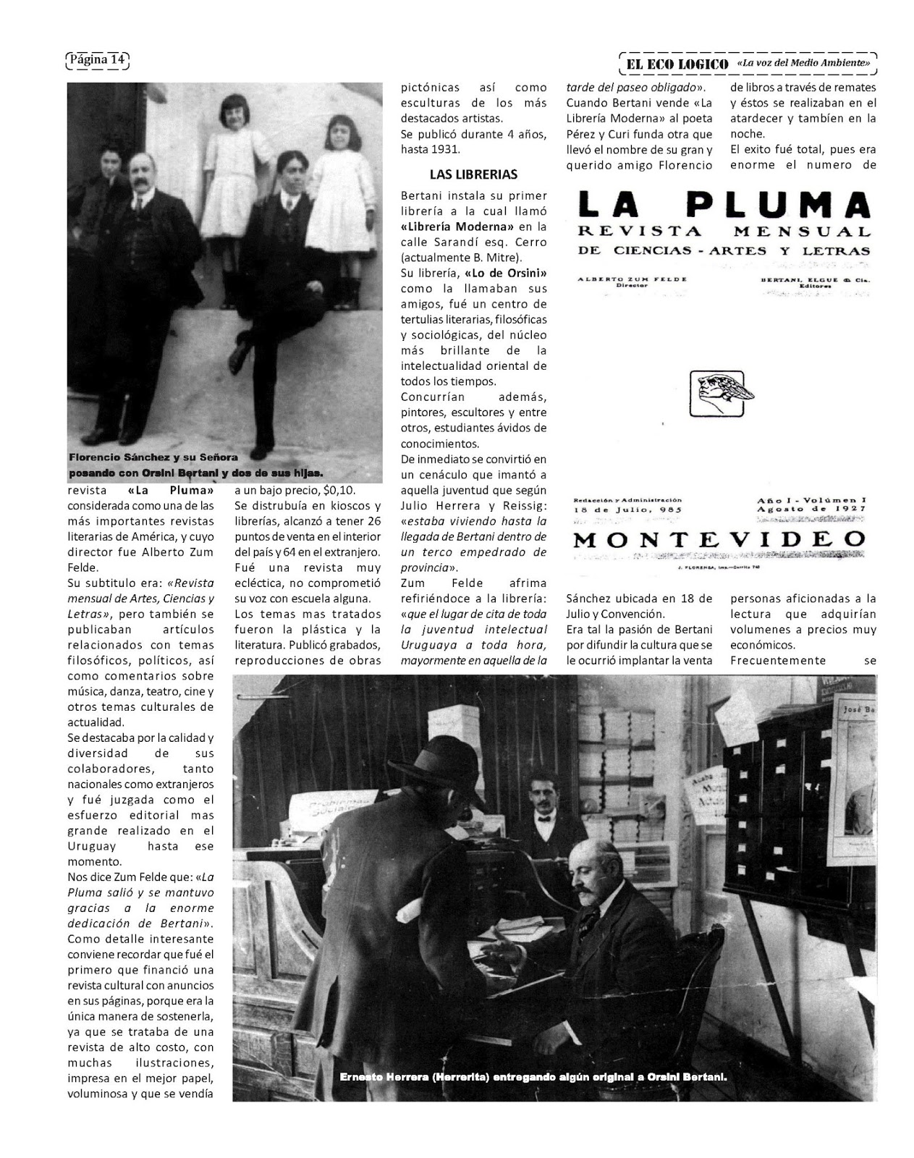

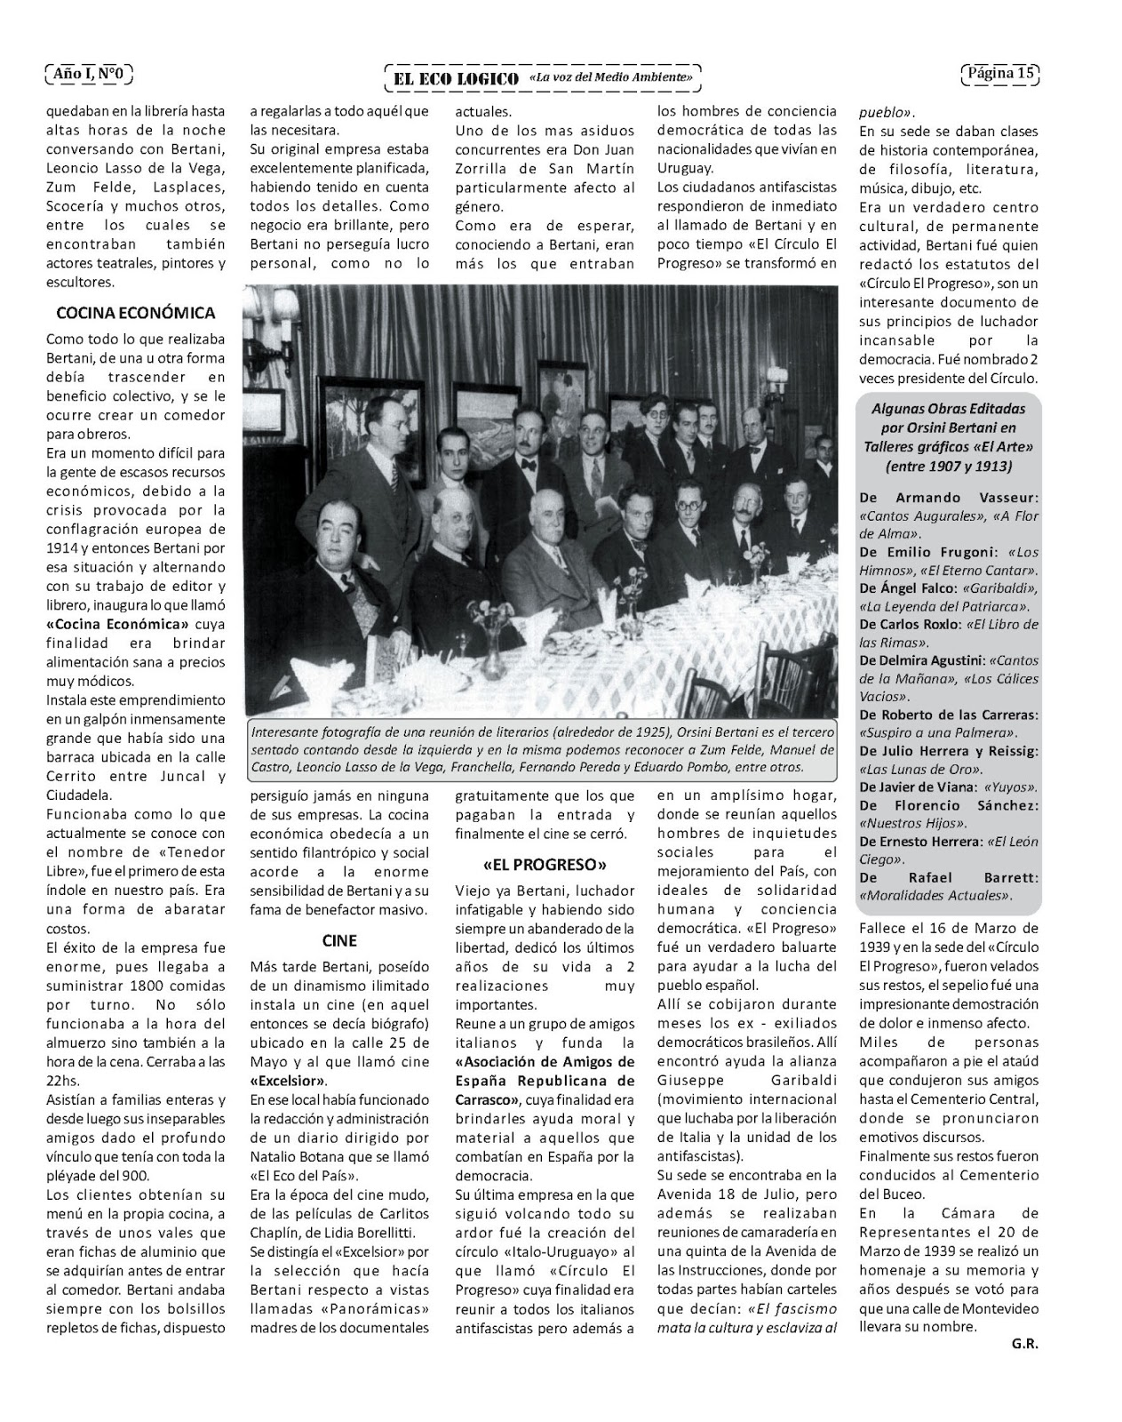
http://orsinibertani.blogspot.com/2013/07/articulo-de-el-eco-logico-sobre-orsini.html

